**Assignment 2**

**1.Use arrays to structure the raw data and to perform data comparison & operations**

**Write a program which creates an integer array and displays sum of its elements.**

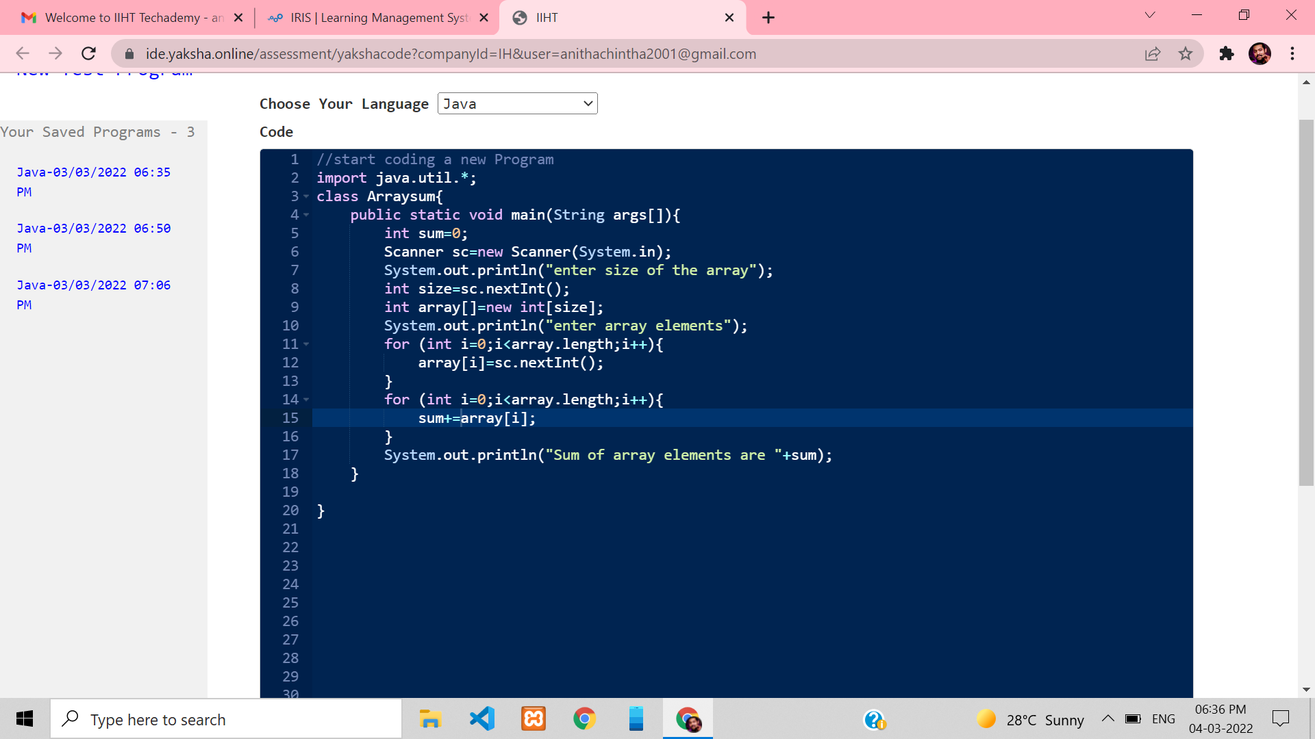

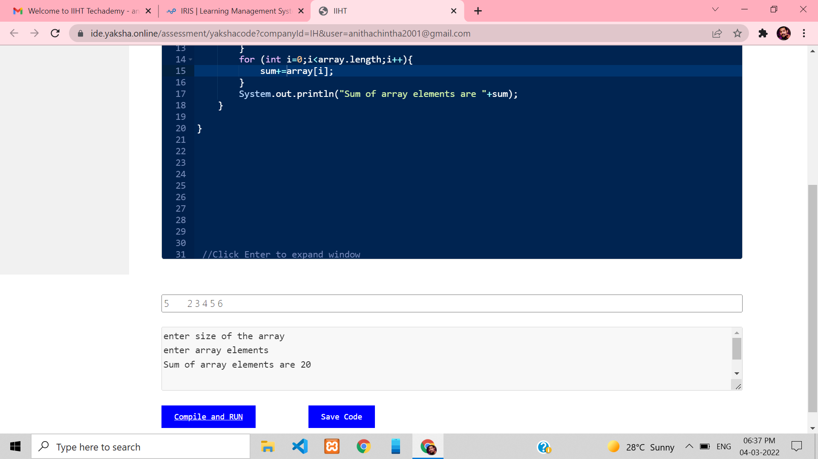

**2.Use arrays to structure the raw data and to perform data comparison & operations**

**Write a program which performs addition of elements which are stored in two arrays of type double.**

**Arrays lengths may be variable in size. The resultant values must be stored in an integer array. Display the resultant integer array in a formatted way.**

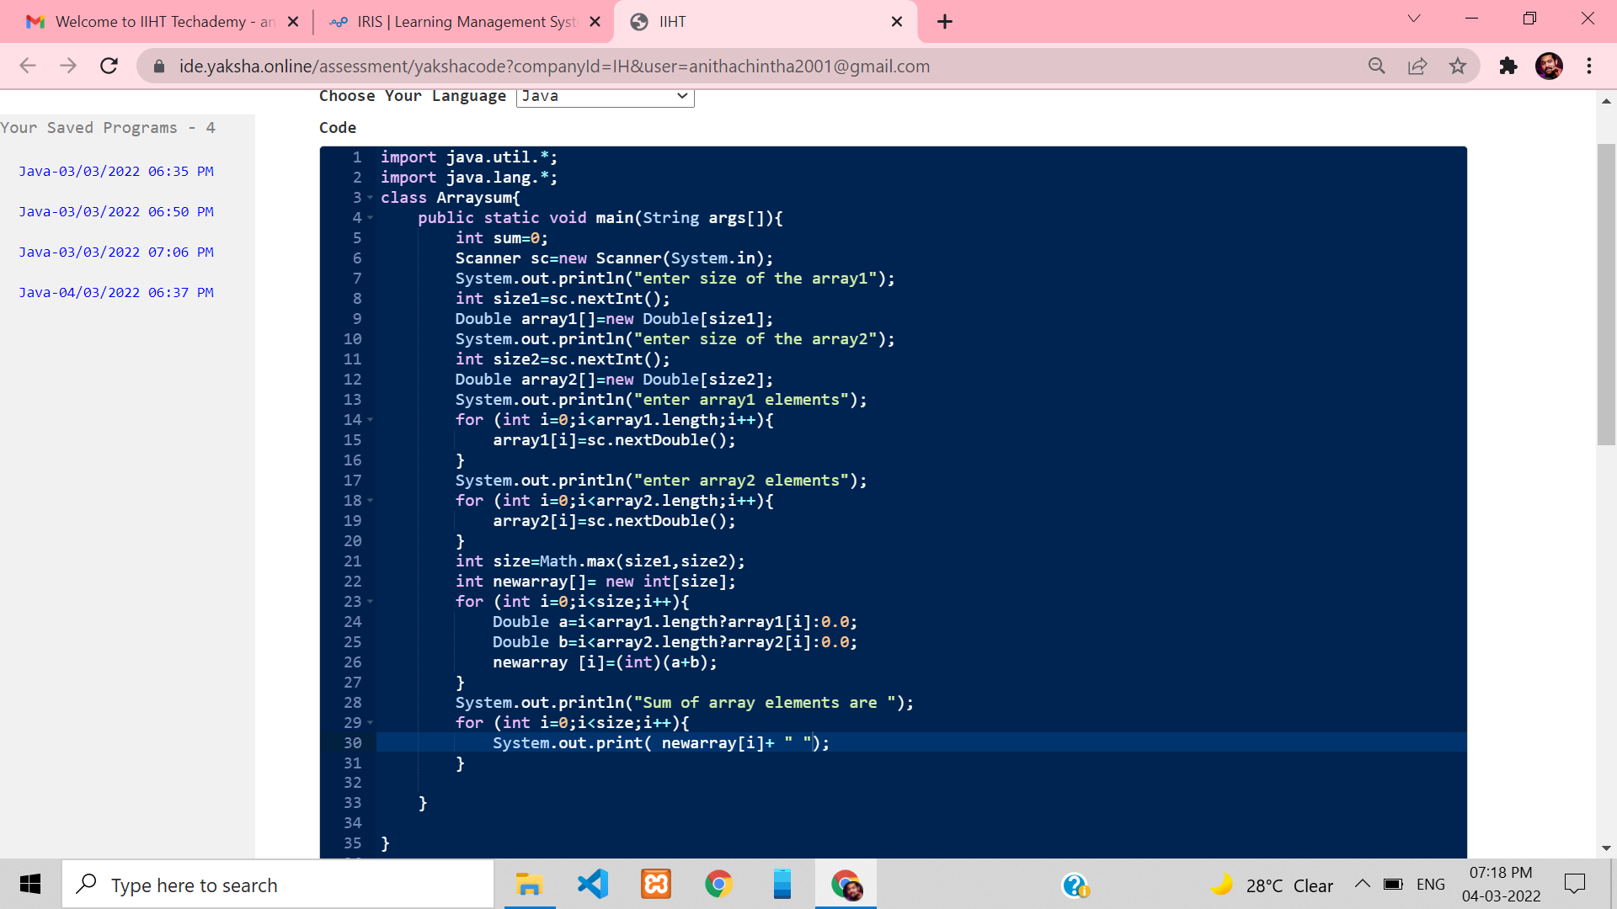

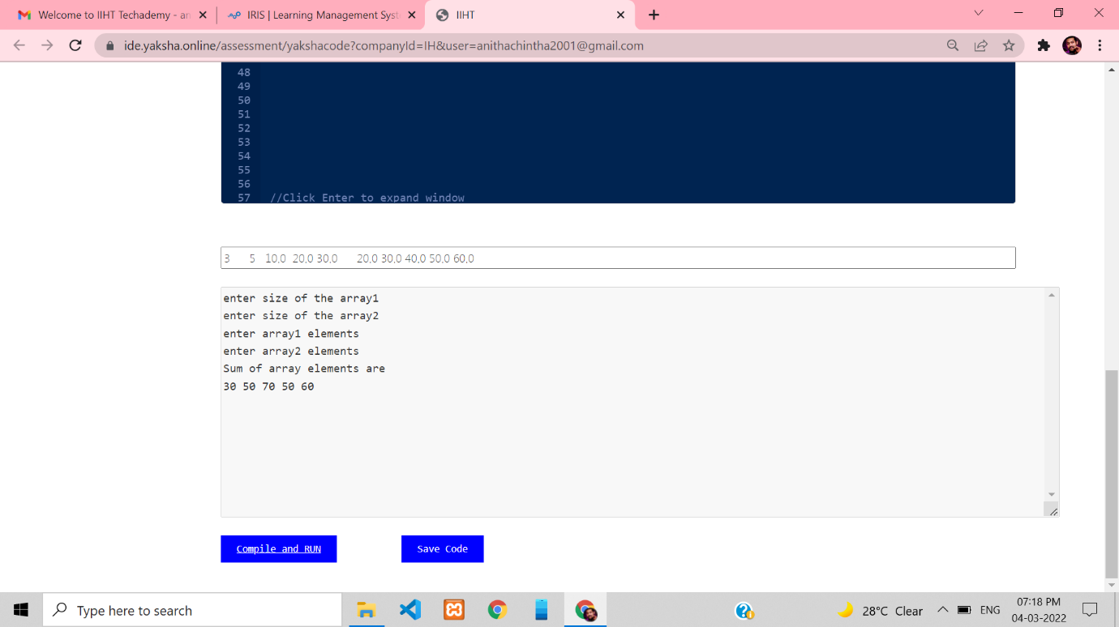

**3.Use arrays to structure the raw data and to perform data comparison & operations**

**Write a method that receives a name as parameter and prints on the console. “Hello, <name>!” Example**

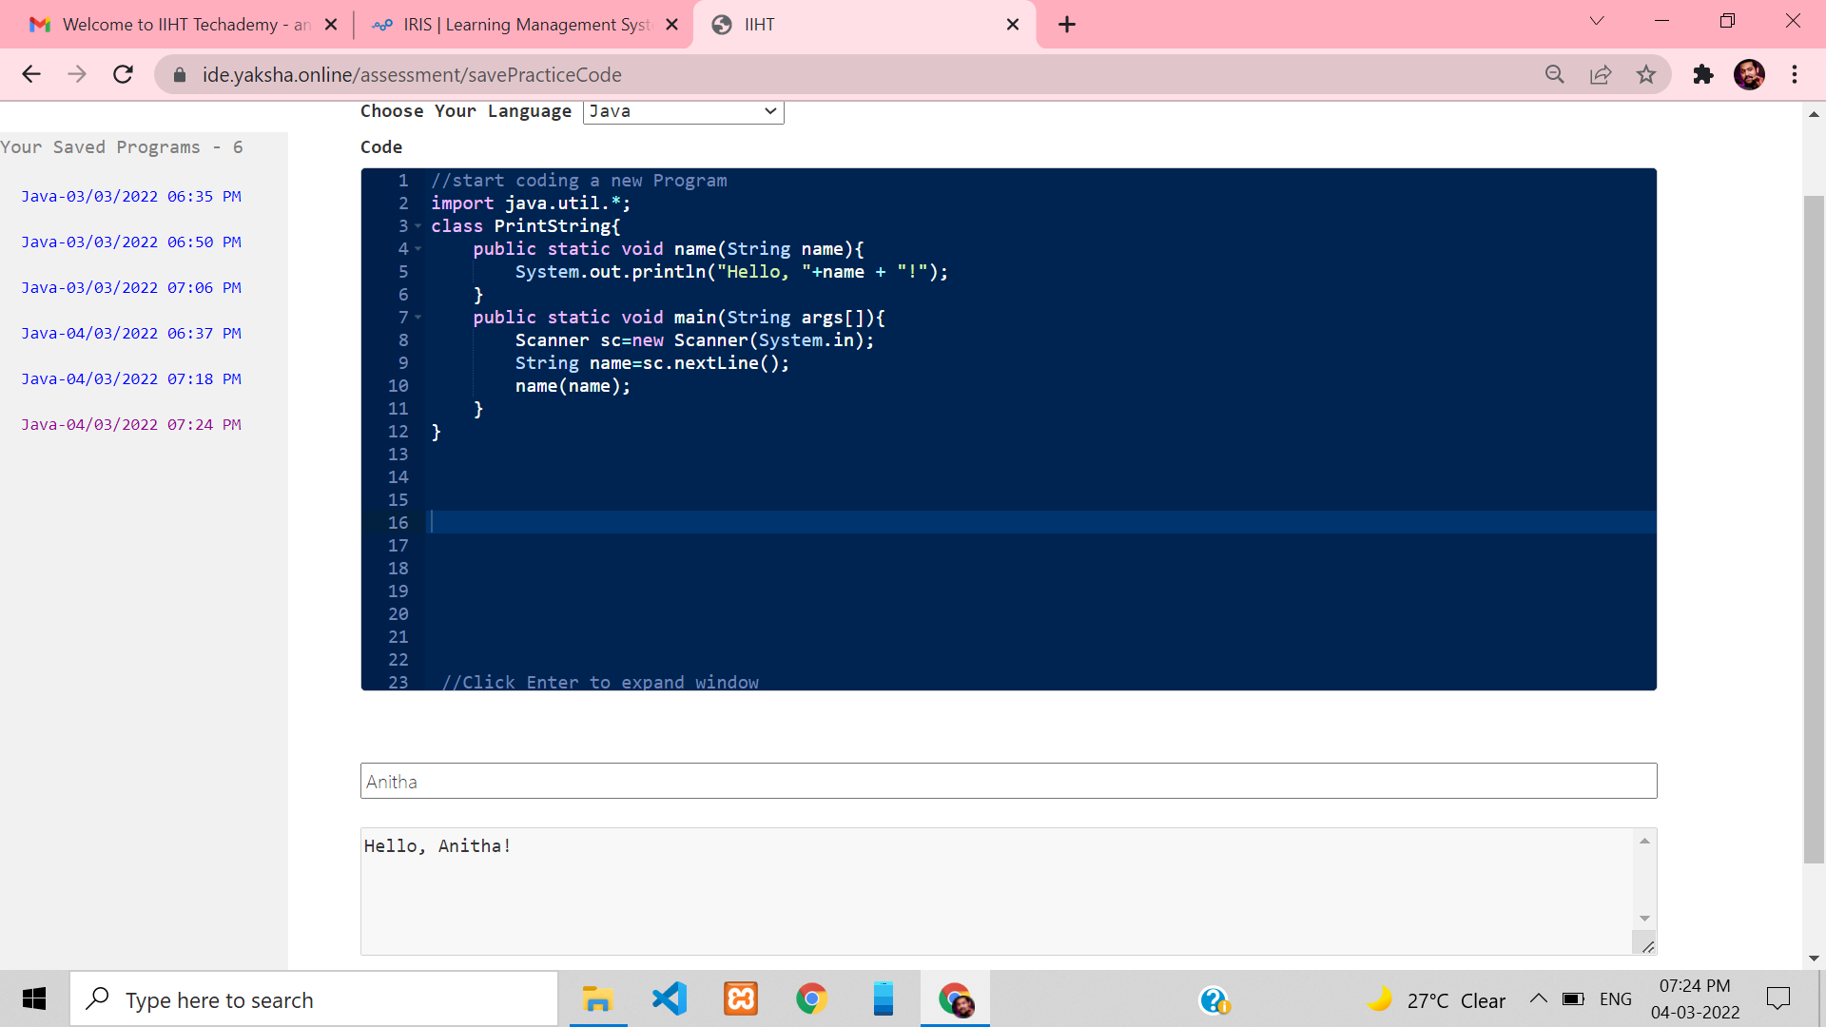

**4.Use arrays to structure the raw data and to perform data comparison & operations**

**Create a method GetMax(int a, int b, int c), that returns maximal of three numbers. Write a program that reads three numbers from the console and prints the biggest of them.**

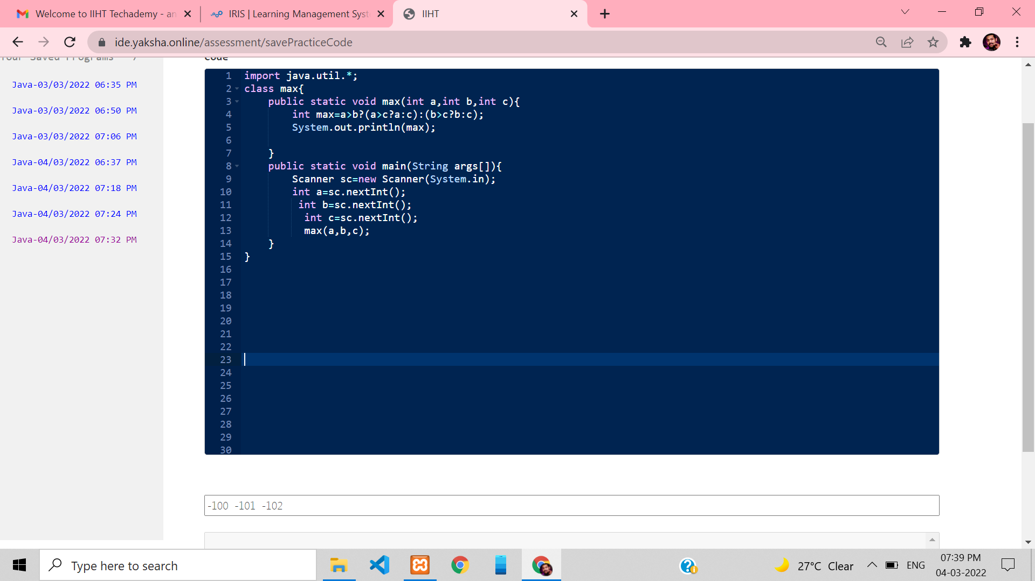

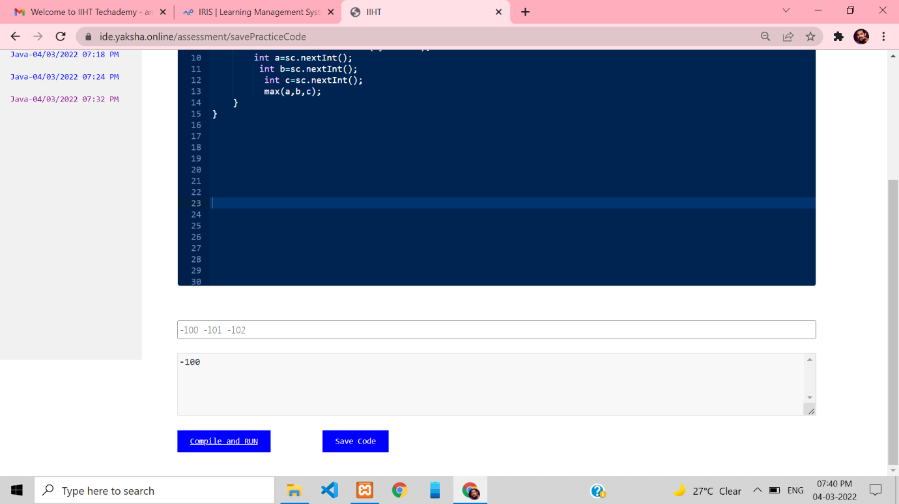

**5.Use arrays to structure the raw data and to perform data comparison & operations**

**Write a method that prints the digits of a given decimal number in a reversed order.**

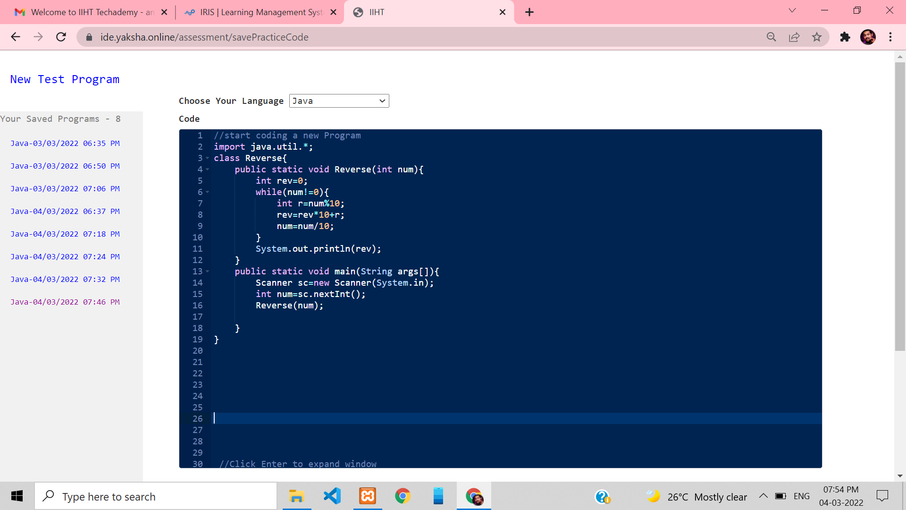

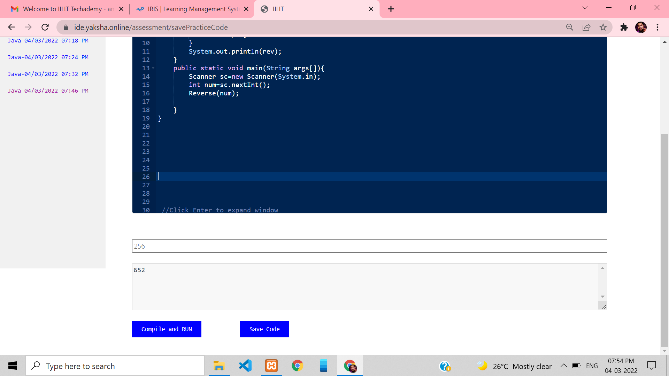

**6.Use arrays to structure the raw data and to perform data comparison & operations**

**Write a Boolean method IsPrime(n) that check whether a given integer number n is prime.**

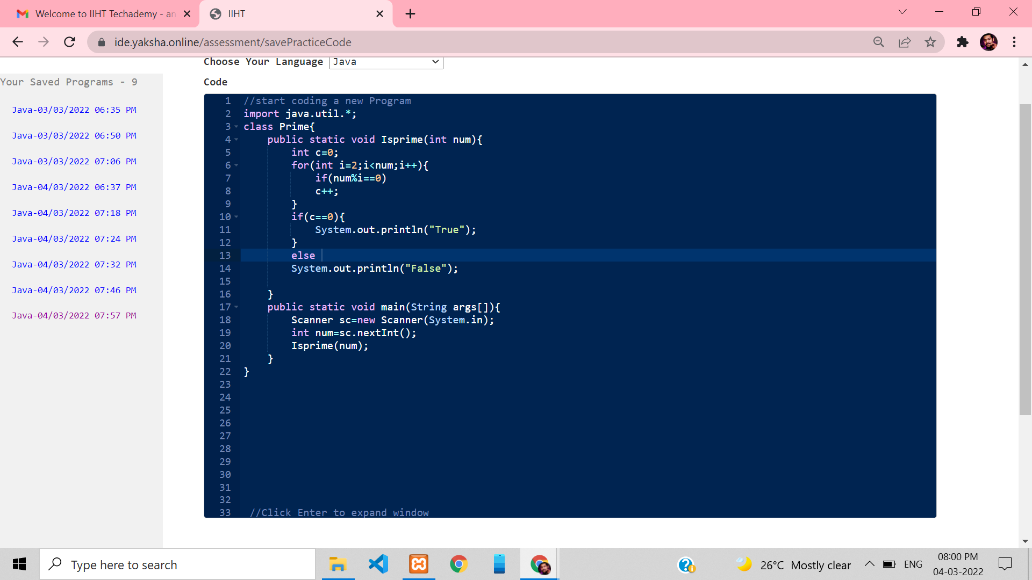

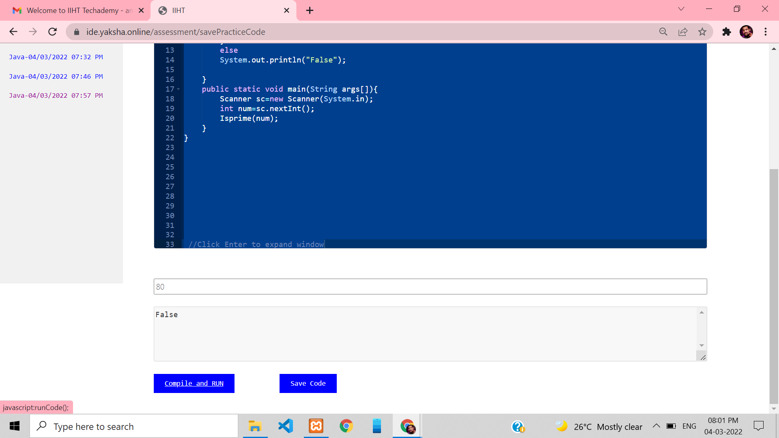

**7.Use arrays to structure the raw data and to perform data comparison & operations**

**Write a method that calculates all prime numbers in given range and returns them as list of integers**

**Write a method to print a list of integers. Write a program that takes two integer numbers (each at a separate line) and prints all primes in their range, separated by a comma.**

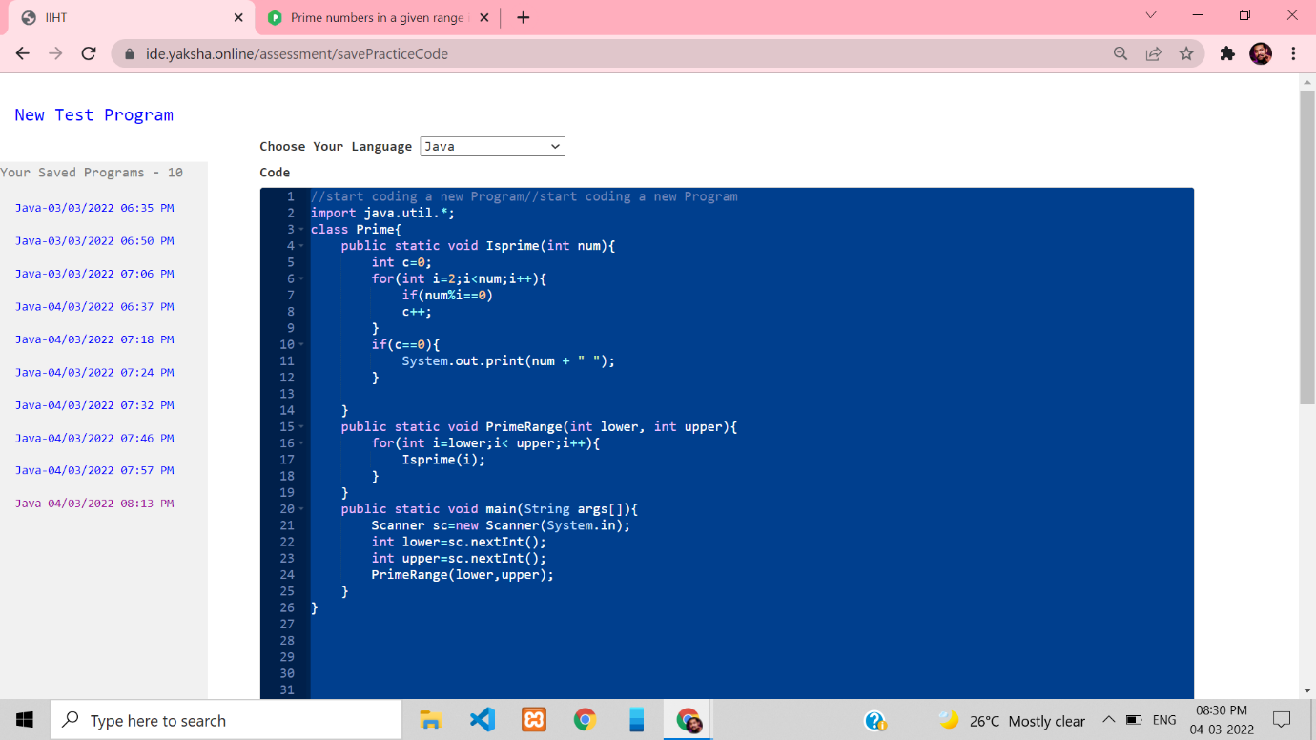

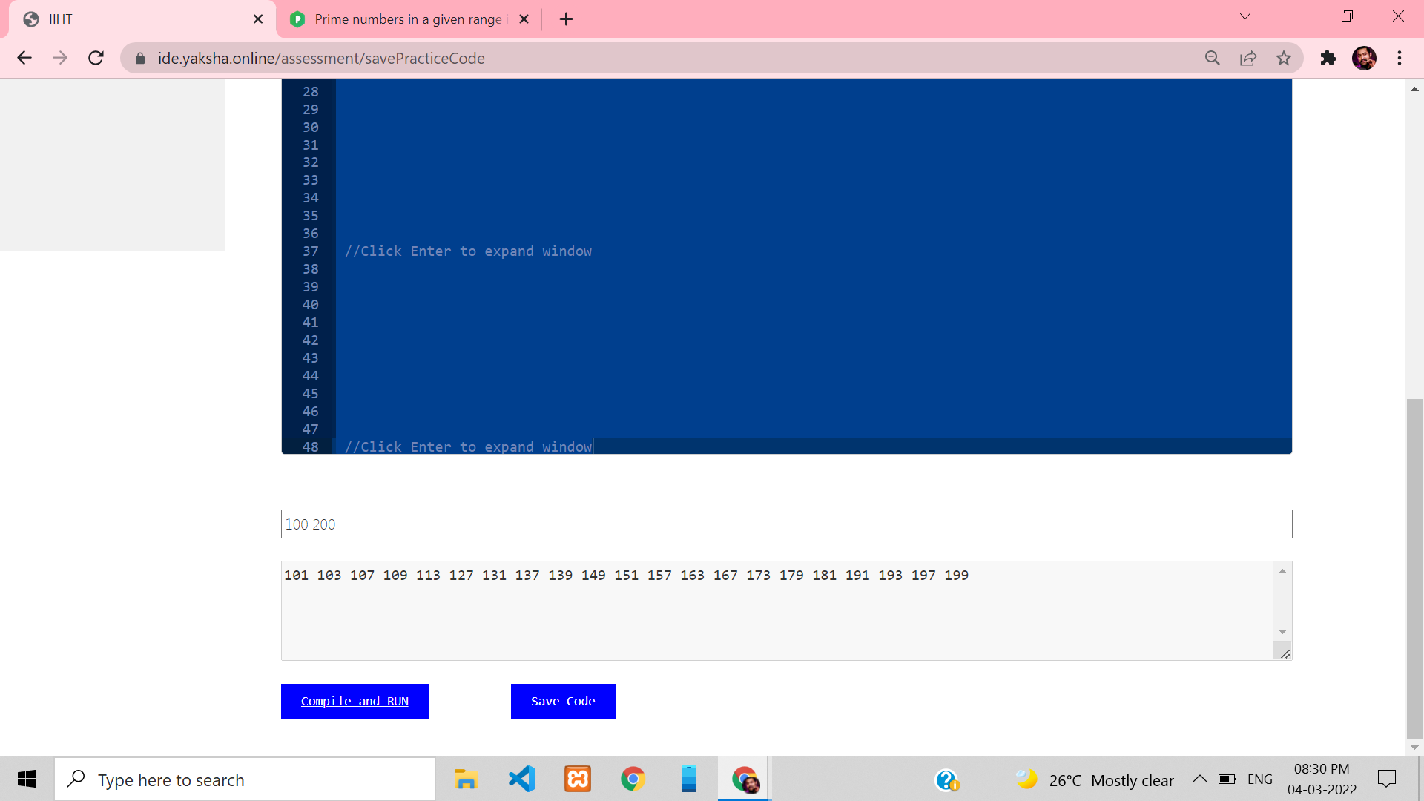

**8.Use arrays to structure the raw data and to perform data comparison & operations**

**Write a program that can calculate the area of four different geometry figures - triangle, square, rectangle and circle.**

**On the first line you will get the figure type. Next you will get parameters for the chosen figure, each on a different line:**

**• Triangle - side and height**

**• Square - side**

**• Rectangle - width and height**

**• Circle – radius**

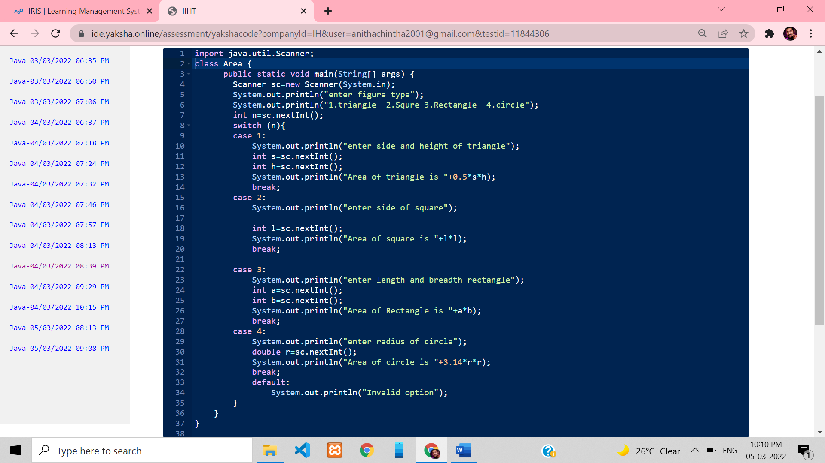

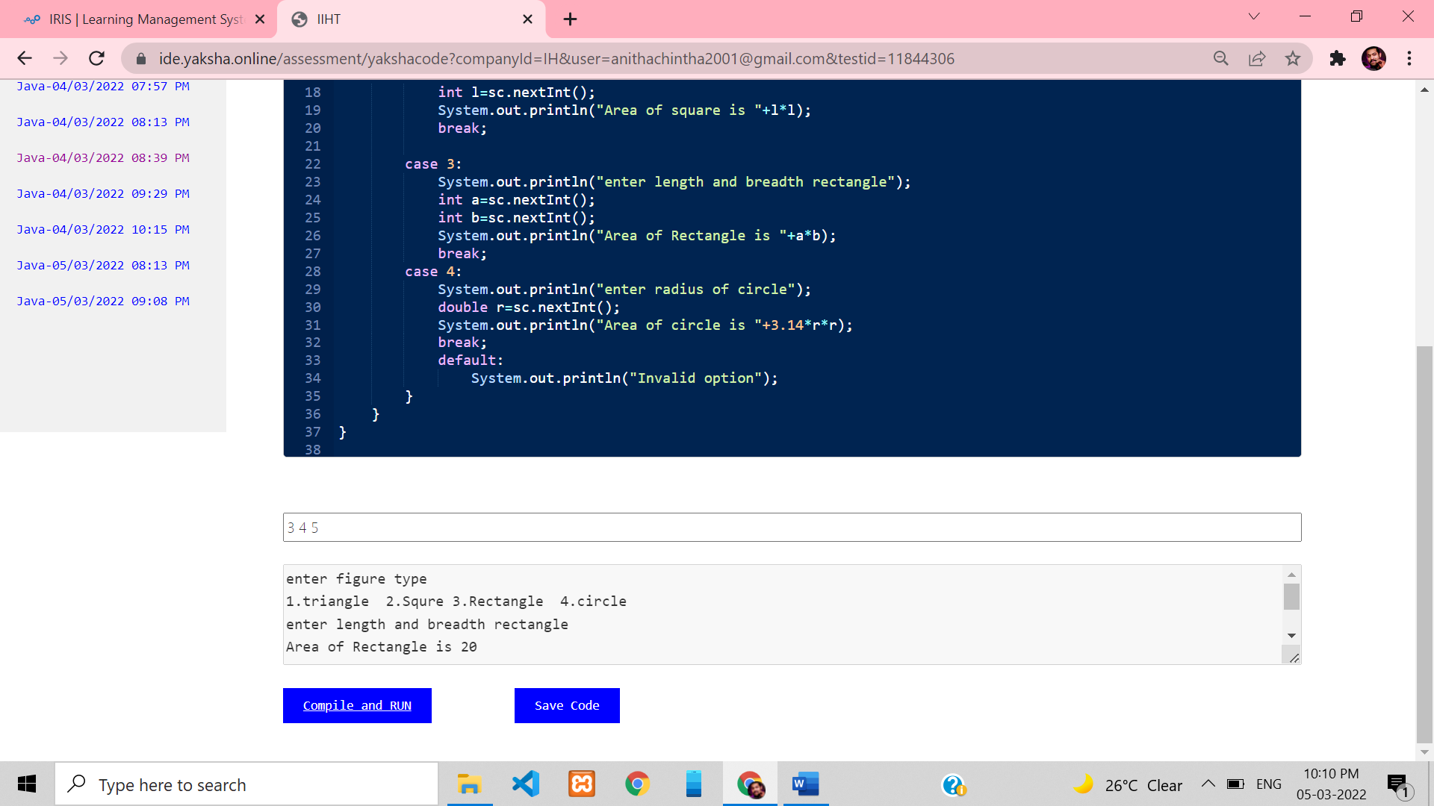

**9.Write a method which accepts two integer arrays and returns an array of unique elements.**

**Example:**

**Array 1 = { 10, 5, 20, 15, 25, 30}**

**Array 2 = {50, 12, 5, 30, 15, 70}**

**Result_Array = {10, 20, 25, 50, 12, 70}**

**Int [] uniqElements(int array1[], int array2[]);**

**Use arrays to structure the raw data and to perform data comparison & operations**

**Analyze below given code and predict the output.**

**Use arrays to structure the raw data and to perform data comparison & operations**

**Write a method which accepts two matrices of Size N X N and returns summation of resultant Matrix.**

**Example:**

**Matrix A: [1,2,3] [4,5,6]**

**Matrix B: [4,5,6] [7,8,9]**

**Matrix C = A + B = [5,7,9] [11,13,15]**

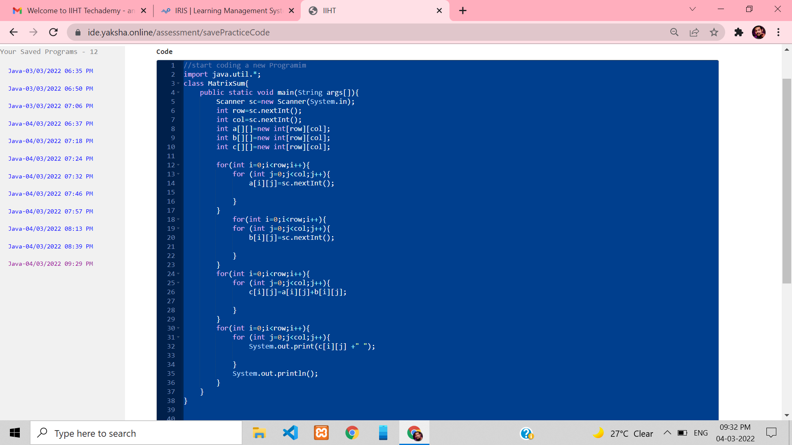

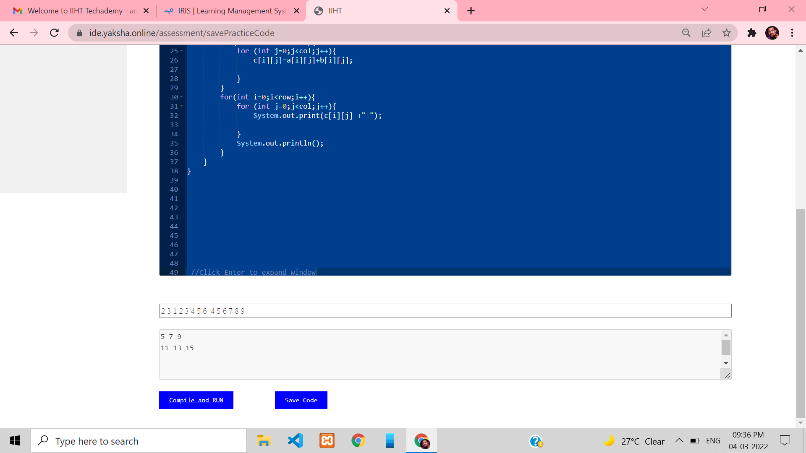

**10.Use arrays to structure the raw data and to perform data comparison & operations**

**Write a method public static boolean isRowMagic(int[][] a) that checks if the array is row-magic (this means that every row has the same row sum).**

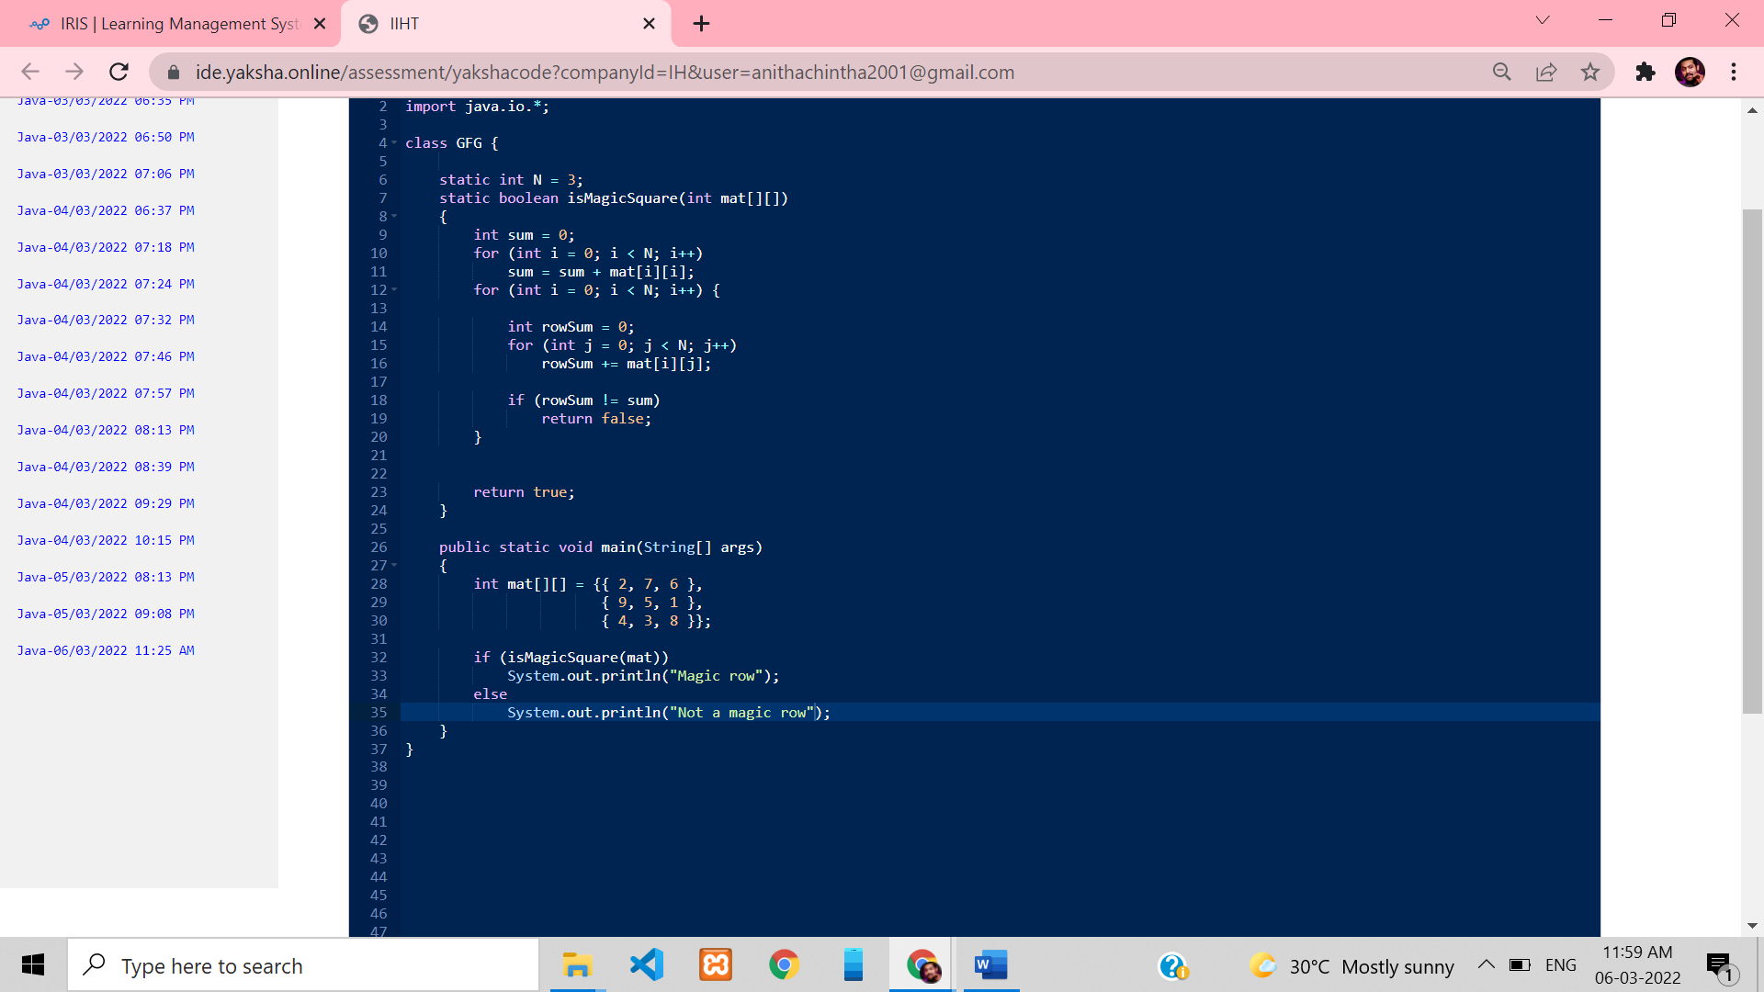

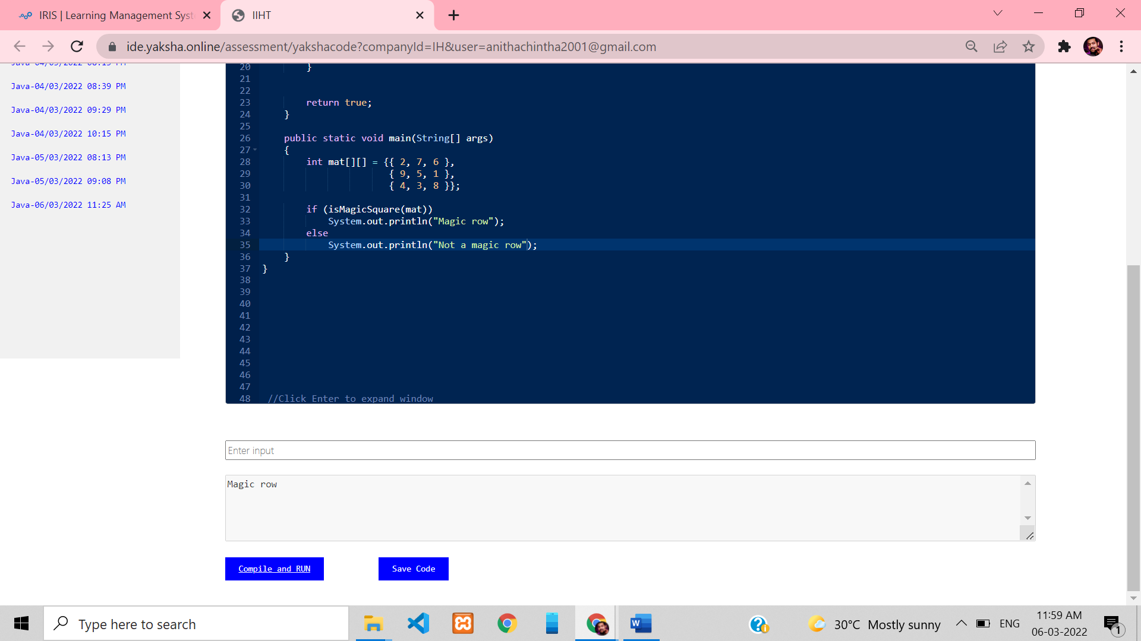

**11.Use arrays to structure the raw data and to perform data comparison & operations**

**Write a method public static boolean isMagic(int[][] a)**

**that checks if the array is a magic square. This means that it must be square, and that all row sums, all column sums, and the two diagonal-sums must all be equal**.

